Camera Shot Sheet
Establishing Shot: An establishing shot in filmmaking and television production sets up, or establishes the context for a scene by showing the relationship between its important figures and objects.
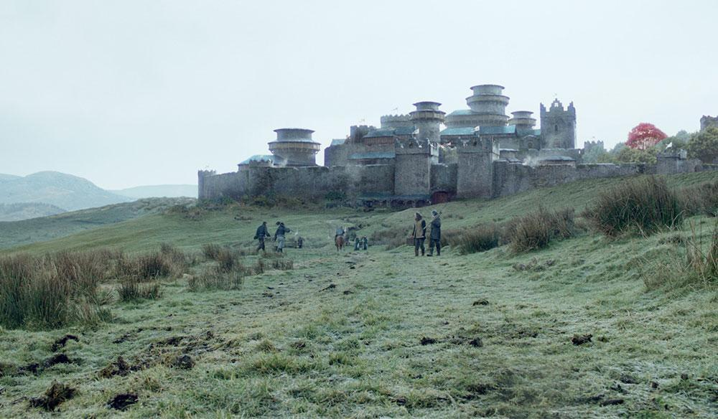

Long Shot: a long shot typically shows the entire object or human figure and is usually intended to place it in some relation to its surroundings.

Medium Shot: In film, a medium shot, mid shot, or waist shot is a camera angle shot from a medium distance.
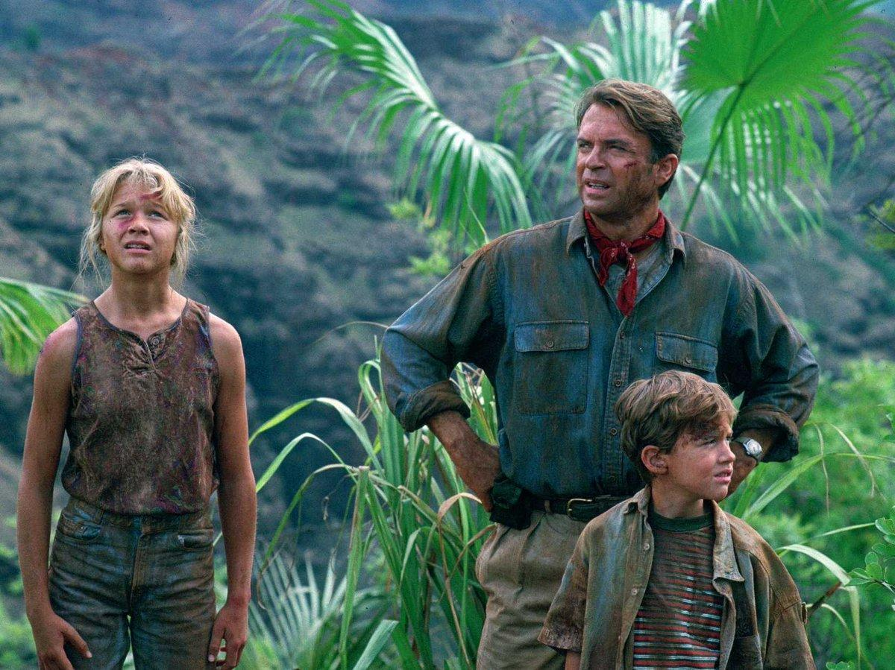

Over the Shoulder Shot: n film or video, an over the shoulder shot is a shot of someone or something taken from the perspective or camera angle from the shoulder of another person.

Close-up: A close-up is a type of shot, which tightly frames a person or an object.
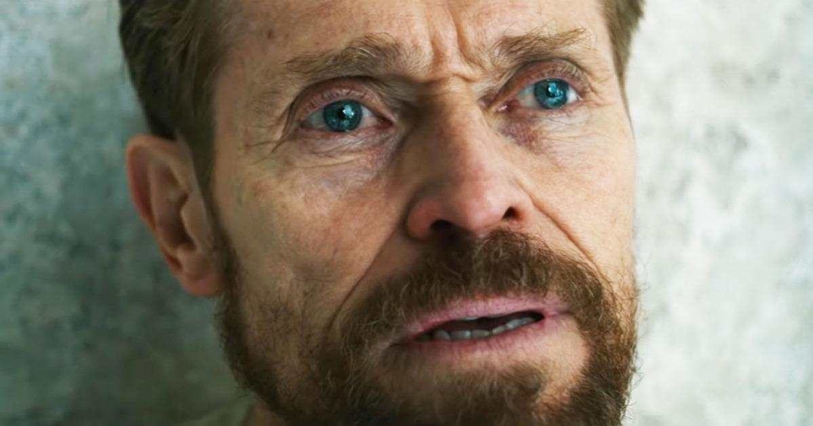

Two Shot: A two shot is a type of shot in which the frame encompasses a view of two people (the subjects). The subjects do not have to be next to each other, and there are many common two-shots which have one subject in the foreground and the other subject in the background. It is very useful if the film is about two people.

Tracking Shot: A tracking shot is any shot where the camera moves alongside the object(s) it is recording. In cinematography, the term refers to a shot in which the camera is mounted on a camera dolly that is then placed on rails – like a railroad track. The camera is then pushed along the track while the image is being filmed.

